Appendix 1: Assignment submission cover sheet
ASSIGNMENT SUBMISSION COVER SHEET
Student Id: cse25-252
Student names: Refilwe Connie Tlhalefang
Student email: cse25-252
Cohort: 2026
Assignment title: 2026 SCIS WMD_2026 A01
Date of submission: 20/03/2026
Programme of Study: Computer Systems Engineering
Year of Study: YEAR 1

Intellectual property statement
By checking the box below, I certify that this assignment is my own work and is free from plagiarism. I understand that the assignment may be checked for plagiarism by electronic or other means and may be transferred and stored in a database for the purposes of data-matching to help detect plagiarism. The assignment has not previously been submitted for assessment in any other unit or to any other institution.
I have read and understood the Botswana Accountancy College plagiarism guidelines policy.
☐ Agree
Signature: R.C.Tlhalefang
Date…20/03/2026……………………………………….

PART A
1.WEBSITE SPECIFICATIONS
a) Website Objectives
Standard Grace (PTY) LTD aims to promote construction services like home building and renovations, attract new customers, institutional supply contracts through lead generation, give details of completed projects, provide company details, and enable easy contract via forms.
- Promote Construction Services- This site will list all services offered by Standard Grace (PTY) LTD including home building renovations, mechanical services (air conditioning, refrigeration, mechanical installations), electrical services (wiring), plumbing services, and civil engineering works (road construction, drainage solutions, paving, bridges, water canal systems, stormwater management, and general site preparation). Each service will feature clear, detailed descriptions for clients to understand

- Showcase Completed Projects- The portfolio section will display completed projects with high-quality before-and-after photos, project timelines, and specifics on materials sourced (e.g., local suppliers for durability) ,we will allow visitors to explore past work, such as renovated homes or road projects, building confidence in the company's ability .

- Provide Company Information- The “About Us” page will include all the company details, company history, licenses core values ( reliability , innovation , safety) .This builds trust by showcasing transparency, experience, and commitment to Botswana's growing infrastructure needs, helping potential clients feel secure partnering with a local, established firm
- Allow Customers to Contact the Company – A Contact page will provide easy access to phone numbers, email address and our location will make it easier for clients to contact

b) Target Audience
The Standard Grace (PTY) LTD website targets contractors, property developers, homeowners, business owners, and organizations needing construction services or material supplies, even schools.
Demographics and Technical Aptitude
- Homeowners (ages 25-45):
Middle-class families living in cities like Gaborone (most people, about 80%, live in urban spots). They have basic computer skills – they use their phones to visit easy websites and search for home repair or building services, like "fix my plumbing".

- Business Owners/Property Managers (ages 30-60):
People who run shops, offices, or manage buildings and need construction help. They have okay skills – comfortable using phones or laptops to fill out forms, read project details, or get quotes online.

- Government/Institutions (ages 35-65):
Officials who handle big public projects like roads or schools. They have good skills – use computers at work and expect websites to be clear, professional, and easy to navigate without confusion.

- Contractors (ages 28-55):
Other builders in Botswana who might team up with Standard Grace. They have medium skills – check photo galleries or past work on phones or laptops to see if they want to partner.

TYPE OF WEBSITE
- Promotional/Services Website: Designed to promote construction services like renovations, electrical wiring, plumbing, AC, and civil works (roads, drainage) – a "brochure" style site to attract clients, generate leads, and display portfolios, as typical for construction firms

- Site Structure: Service pages with clear lists/descriptions, project galleries (before/after photos for trust), About Us (history/licenses), contact forms – matches expert advice for builders to highlight "project portfolios" and "secure contracts".

- Promotional Purpose: Construction marketing uses sites for "generating leads, building brand awareness" in industries like Botswana's (7% workforce in construction).

2.INFORMATION DESIGN & TAXONOMY

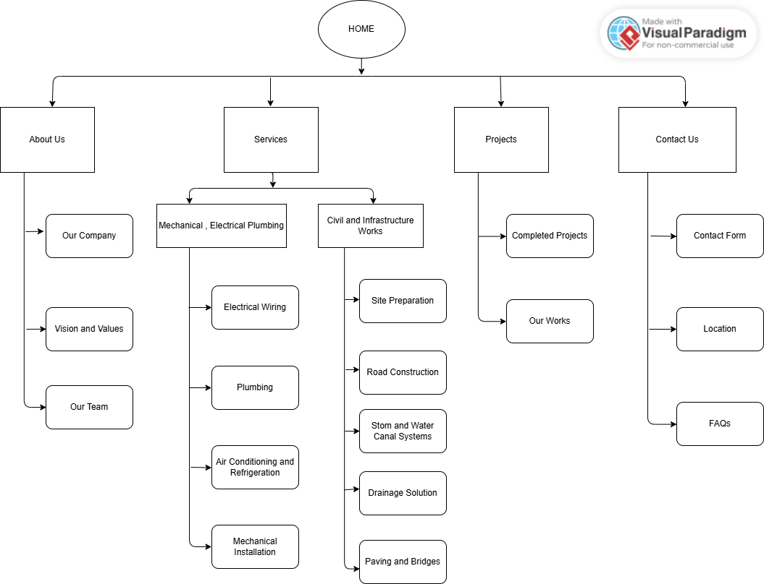

4. TECHNICAL BRIEF
Overview
The website for Standard Grace (PTY) LTD will be developed using a combination of modern web technologies and design tools to ensure a professional, responsive, and user-friendly platform. The aim is to effectively present the company’s construction, renovations, MEP services (wiring, plumbing, AC), and civil works (roads, drainage) and maintenance with fast loading and easy navigation for clients while maintaining high performance and accessibility.
Web Development Technologies
- HTML5 (HyperText Markup Language) - HTML will be used to build clean web pages and structure the content of the website. It will be used to provide the foundation of these web pages, including all the elements.
- CSS3 (Cascading Styles Sheets) - CSS3 will be used to design and style the website, making it look professional on different browsers and devices. This will also control the layout of the website, the color, fonts, and spacing.
- JavaScript- JavaScript will be used to add interactivity to the website, form validation being the required fields, before/after projects
Development Tools
- Code Editor-Visual Studio Code-Visual Studio Code will be used for writing and editing code because it is user friendly and debugging capabilities
- Web Browser-Google Chrome-Google Chrome will be used for testing and debugging the website using developer tools to inspect elements and fix errors
Design and Planning Tools
- Visual Paradigm- Visual Paradigm will be used to design site maps for my website and flowcharts. This helps in planning the structure and navigation of the website before development

Testing Tools
- W3C Validator-Ensures the site works across all different browsers
Graphics & Media Tools
- Canva – Canva will be used to create simple graphics, service icons, and construction images to help attract users and make the site more appealing

